Dear Parents and Carers,
A very warm welcome back to all our children and families at Byker Primary School. We hope you have enjoyed a happy and restful summer break and are looking forward to the exciting year ahead.
School will reopen to pupils on Wednesday 2 September 2026 at 8:45am.
Building Work:
A number of repairs and improvements have been carried out during the summer holidays. These include:
- a new roof;
- groundwork for the new football court due for completion in October 2026;
- new outdoor furniture for Nursery and Pre-school; and
- classroom alterations to create two therapeutic learning spaces.
Work is continuing on the new girls’, boys’ and accessible toilet facilities near the gym. As this work is not yet complete, contractors will continue to require access to certain areas of the school for the next few weeks.
Appropriate fencing and safety procedures are in place to keep children and families safe and to ensure that all safeguarding requirements are followed. However, the ongoing work means that there will be some temporary changes to how pupils in Years 3–6 enter and leave school.
Please carefully read the arrangements below so you know what you will see on entrance to the main yard and arrangements for drop of and collections:
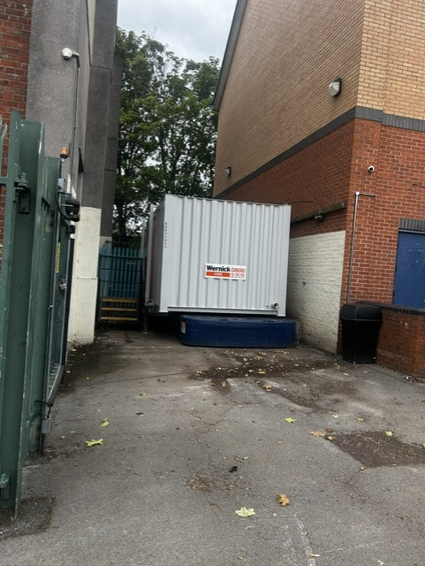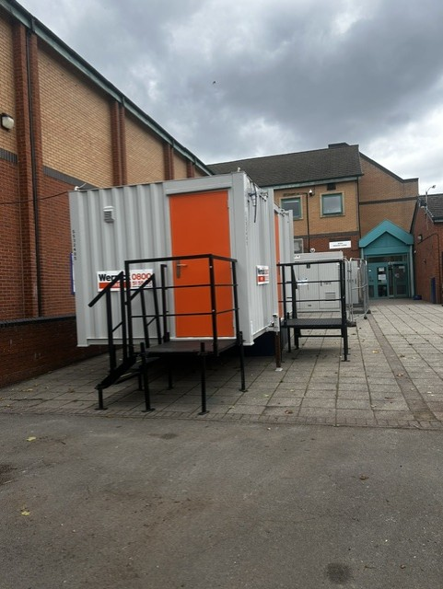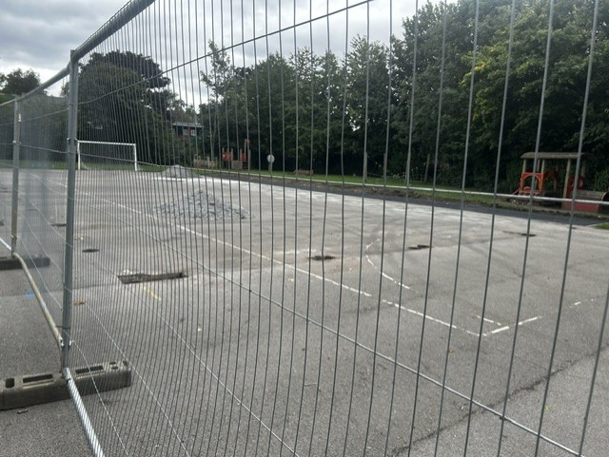

EYFS (Pre-school, Nursery, Reception): There are no changes to how your child will enter and leave school/classroom.
Year 1 and Year 2: There are no changes to how your child will enter and leave school/classroom. We kindly ask families to keep a clear pathway so that pupils in Years 3–6 can safely walk across the main yard to the tyre zone at drop-off and collection times.
Year 3,4,5,6: Drop Off
- Families will not be able to enter the school through the gym, as this area is closed.
- Please remain on the main yard with your child until the bell rings.
- When the bell rings, pupils should walk to the tyre zone and line up beside the member of staff holding their year-group sign.
- Each class will then enter the school together under staff supervision.
- Once your child has joined their line, please leave the school yard promptly. This will help to prevent overcrowding and allow pupils to enter the building safely.
Year 3,4,5,6: Pick Up
- Pupils will leave the building in their class line through the main entrance and walk to the tyre zone on the main yard.
- Parents and carers must wait outside the tyre zone.
- Please do not enter the tyre zone or take your child directly from the line.
- A member of staff will call and release each child to their parent or carer. This ensures that every pupil is safely handed over and properly accounted for.
Please remain patient and courteous while staff safely release pupils at the end of the day. These arrangements are in place to protect all our children.

Tyre Zone image of where to line up and where parents may stand:
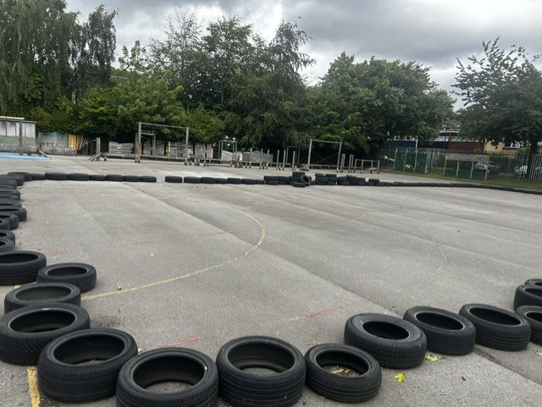
5.11
4.100
4.7
3.9
3.8
6.14
6.13
5.12
Blue Arrow: This is where the children will line up
Orange Lines: This is where we ask parents to stand behind the tyres on all 4 sides and wait for your child to be released by the class teacher.
Thank you for your patience, understanding and cooperation while this important work is completed. We look forward to welcoming everyone back and beginning another successful year of learning, friendship and achievement at Byker Primary School.

