Dear Parents and carers,
Healthy packed lunch
We understand that preparing packed lunches can be a challenge, and we are working to support you in making healthy choices for your children. Our guidelines are based on national standards and are intended to provide a healthy and nutritious midday meal for all pupils. All packed lunches should contain a starchy food, protein, vegetable/fruit and dairy element to be balanced.
Please see below for some health packed lunch ideas.
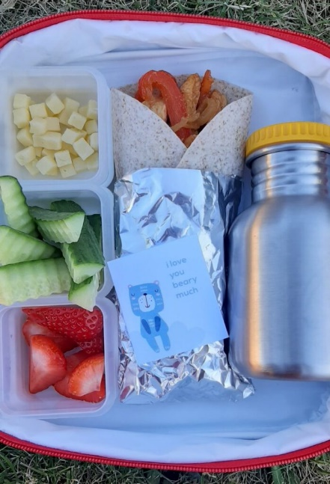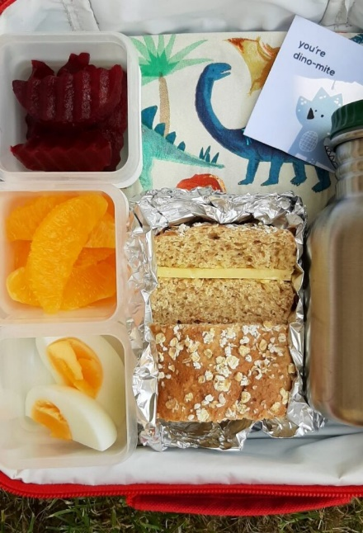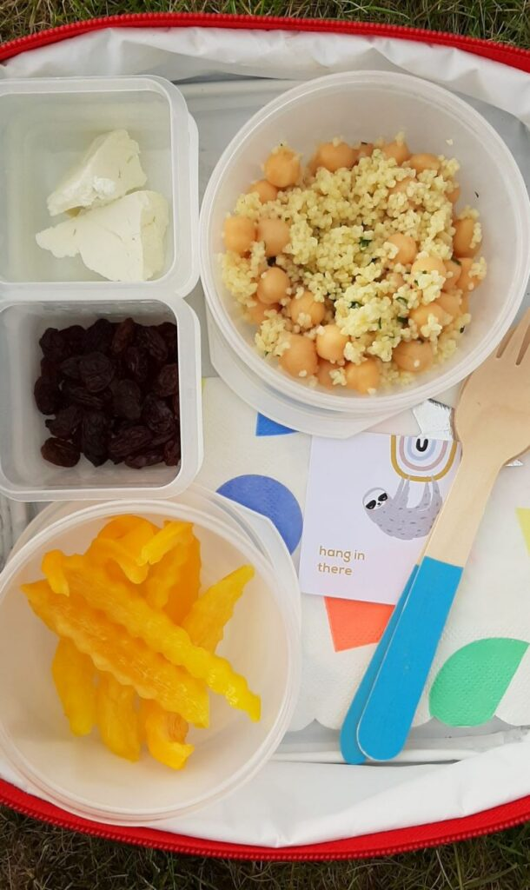
Bento Box Lunch
A bento-style box is an excellent way to provide variety and encourage portion control.
- Starchy food: Wholemeal crackers or a small whole-wheat wrap cut into triangles.
- Protein: Slices of lean chicken or a hard-boiled egg.
- Vegetables: Cucumber slices, carrot sticks, and bell pepper strips for dipping.
- Fruit: Strawberries and blueberries.
- Dairy: A portion of plain yogurt or a cheese stick.
Pasta Salad Lunch
Leftover pasta can be repurposed into a healthy and filling packed lunch.
- Starchy food: Whole-wheat pasta.
- Protein: Cubed chicken, chickpeas, or tuna.
- Vegetables: Cherry tomatoes, sweetcorn, and chopped cucumber.
- Dairy: A sprinkle of grated cheese.
- Fruit: A banana.
Sandwich-free Lunch
Switching from sandwiches can add excitement and variety to lunchtimes.
- Starchy food: Wholemeal pitta bread for dipping.
- Protein: A small pot of hummus or a few falafel balls.
- Vegetables: Carrot and cucumber sticks.
- Dairy: A small pot of plain yogurt.
- Fruit: A colourful fruit kebab with grapes (halved) and melon chunks.
Fun and colorful Lunch
Making lunch visually appealing can encourage children to eat more fruits and vegetables.
- Starchy food: A wholemeal bagel with cream cheese.
- Protein: Sliced ham or turkey.
- Vegetables: Edamame and sliced peppers.
- Fruit: An apple, perhaps with a squeeze of lemon juice to prevent browning.
- Dairy: String cheese.

