Uniform Policy

Byker Primary School


Approved by:
Approved Date:
Review frequency: | Annually
Next Review Date:

1 Purpose

The purpose of this policy is to:
- set out our approach to requiring a school uniform that is of reasonable costs and offers the best value for money for parents and carers;
- explain how we will avoid discrimination in line with our legal duties under the Equality Act 2010; and
- clarify our expectations for school uniform.

2 Scope

This policy applies to all school pupils.

3 Policy statement

- We believe that a consistent school uniform policy is vital to promote the ethos of the school and provide a sense of belonging and identity for all pupils, regardless of their protected characteristics or socio-economic circumstances.
- We believe that pupils learn most effectively and achieve their best outcomes when they are comfortable, able to be themselves, and dressed in such a way that sets an appropriate tone for education.
- We aim to ensure a consistent, fair and inclusive uniform policy, and to implement a uniform that reflects the needs of all pupils, and is affordable and the best value for money for the school and pupils’ families.
- We will make sure that the school’s uniform supplier arrangements give the highest priority to cost and value for money, for example by avoiding single supplier contracts and by re-tendering any contracts at least every 5 years. If we intend to change suppliers, we will do so in good time before the start of the next school year.
- In accordance with the Department for Education’s School Admissions Code, we will ensure that this policy does not discourage parents from applying for a place for their child.

4 Legal considerations

The policy is written to ensure that we comply with various education and data protection legislation, as well as the Human Rights Act 1998 and the Equality Act 2010.

We have given due regard to the Department for Education’s non-statutory guidance on school uniforms and statutory guidance on the cost of school uniforms.

5 Roles and responsibilities

- Governing Body: has delegated responsibility for the approval and monitoring/review of this policy and ensuring the school’s uniform is accessible, affordable and inclusive.

- Head Teachers: are responsible for ensuring the uniform policy is consistently implemented and that staff understand what to do if a pupil is in breach of the policy or if an amendment to the policy is requested for an individual pupil in relation on the basis of their protected characteristics or socio-economic circumstances.

- Staff: are expected to monitor pupils to make sure they are in the correct uniform and to deal with any breaches of the policy fairly and consistently in accordance with the school’s Behaviour Policy. This will include communicating with parents/carers and taking a mindful and considerate approach where families are experiencing barriers to complying with the policy.

- Parents/carers: are expected to ensure their child has the correct uniform and PE kit, and that every item is clean, presentable and clearly labelled with the child’s name. They are also expected to contact the Head Teachers/Senior Leaders if they want to request an amendment to the uniform policy in relation to their child’s protected characteristic(s) or the cost of uniform.

- Pupils: are expected to wear the correct uniform at all times unless an individual amendment has been agreed, other than on specified non-school uniform days. This means on the school premises, travelling to and from school and, if specified, at out-of-school events or trips that are organised by the school, or where they are representing the school.

6 Our commitment to limiting the cost of school uniform

We recognise that we have a duty to make sure that the uniform we require is affordable. We will do this by:
- carefully considering whether any items with distinctive characteristics (e.g. school logos or branding) are necessary;
- limiting any items with distinctive characteristics where possible
- considering cheaper alternatives to school-branded items;
- avoiding specific requirements for items pupils could wear on non-school days, such as coats, bags and shoes;
- keeping the number of optional branded items to a minimum;
- avoiding different expensive uniform requirements for different year/class/house groups;
- avoiding different uniform requirements for extra-curricular activities;
- seeking to work with multiple suppliers to obtain the best value for money possible;
- making sure that arrangements are in place for parents to acquire second-hand uniform items;
- avoiding frequent changes to uniform specifications and minimising the financial impact on parents/carers of any changes;
- consulting with parents and pupils on any proposed significant changes to the uniform policy; and
- carefully considering any concerns or complaints about the cost of uniform.

We will assess the overall cost implications of our uniform policy regularly, including prior to making any changes to the school uniform. When evaluating whether costs are reasonable and proportionate, we will take into account the opinions and situations of:
- economically disadvantaged parents;
- parents with multiple children who are, or will be in the future, pupils at the school;
- parents of younger children, as they are likely to grow quickly and require new sets of uniform more frequently;
- parents of pupils with protected characteristics that may impact their ability to access the uniform due to costs; and
- looked after children and previously looked after children.

We will evaluate the cost of our uniform based on the overall collection of uniform items that parents/carers would need to purchase for a pupil, rather than on the cost effectiveness of individual items. This will include consideration of the fact that parents will need to purchase multiples of certain items, e.g. shirts and socks, to ensure their child can come to school in clean uniform every day.

We will ensure that the socio-economic situation of pupils is considered when identifying the uniform required by the school. However, where the individual needs of pupils cannot be met within the standard uniform specified due to reasons of cost, individual amendments to the uniform will be considered and permitted on a case-by-case basis and we are committed to finding a mutually acceptable solution wherever possible.

7 Our commitment to our legal duties under the Equality Act 2010

We take very seriously our legal obligation to avoid unlawfully discriminating against pupils on the basis of any protected characteristic which includes sex, race, religion or belief, gender reassignment.

We aim to be as inclusive as possible so that all pupils are supported to access a school uniform which is comfortable, suitable for their needs, and reflects who they are.

To avoid discrimination, we will:

- make sure that our uniform costs the same for all pupils, regardless of whether or not they have a protected characteristic;
- allow all pupils to have long hair, although we reserve the right for this to be tied back;
- allow all pupils to style their hair in the way that is appropriate for school, yet makes them feel most comfortable;
- consider the needs of pupils with SEND and/or sensory difficulties e.g. ensuring soft, stretchy fabrics and avoiding intricate buttons or hard seams;
- allow pupils to request changes to swimwear for religious reasons;
- allow pupils to wear headscarves and other religious or cultural symbols; and
- carefully consider requests from pupils or parents/carers for amendments to our policy on the grounds of equality.

We will ensure that parents/carers and pupils are consulted over any changes to school uniform, and that views and advice are sought specifically from pupils, and parents/carers of pupils, who:
- are transgender, including non-binary pupils;
- have SEND and/or sensory needs; and/or
- are of a religious or cultural background that has dress requirements.

We will ensure that the needs of pupils with protected characteristics are considered when identifying the uniform required by the school. However, where the individual needs of pupils cannot be met within the standard uniform specified on the basis of their protected characteristic(s), individual amendments to the uniform will be considered and permitted on a case-by-case basis and we are committed to finding a mutually acceptable solution wherever possible.

8 Expectations for school uniform

Clothing
The school uniform is as follows:

Item | Optional or required item | Branding | How to acquire | Cost per item from school supplier
Regular school uniform
Blue sweatshirt or cardigan | Required  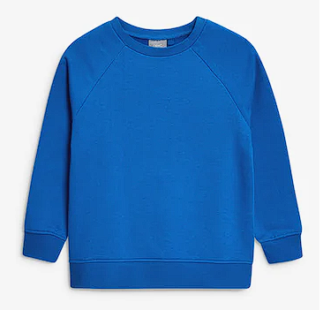 | School logo - optional  No branding | Available from uniform supplier  Can be bought from regular retailers | From £8.75  From £6.00  (2 pk)
White Polo Shirt (pre-school - Year 6) | Required  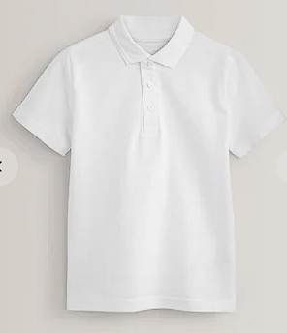 | No branding | Can be bought from regular retailers | From £2.50 (2pk)
Grey or Black  Trousers/  Shorts/Skirt  /Pinafore | Required  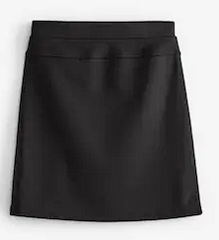  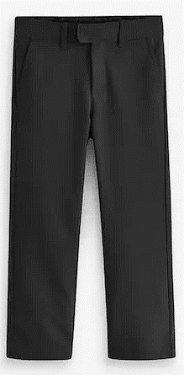 | No branding | Can be bought from regular retailers | From £3.00
Summer Dress (Blue & White | Optional  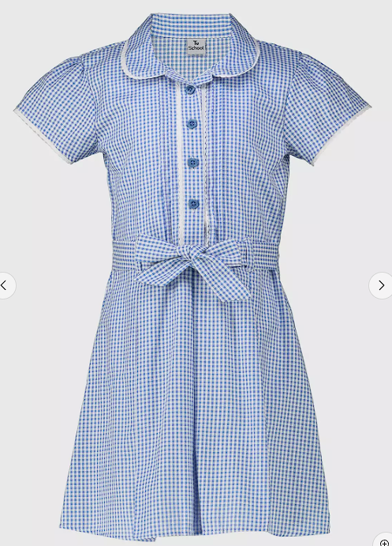 | No branding | Can be bought from regular retailers | From £5.50
Sensible black flat shoes or trainers | Required  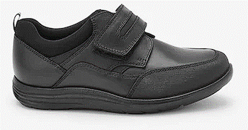 | No branding | Can be bought from regular retailers | Est: from £10
Outdoor Blue Fleece Jacket | Optional  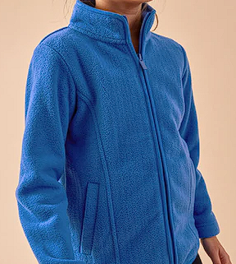 | School Logo optional  No branding | Available from uniform supplier  Can be bought from regular retailers | From £12.25  From £3.99
Waterproof coat | Optional | No branding | Can be bought from regular retailers | Est: from £10.00
PE kit
All PE Kits are provided for and cleaned by School for Reception-Year 6 pupils.

They consist of Blue T-Shirt, Blue Shorts, PE Bag.

You must ensure, however children have appropriate footwear.
CROCS are not allowed for PE lessons
Plimsolls/  trainers | Required  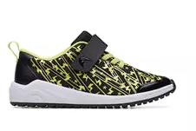 | No branding | Can be bought from regular retailers | From £3.00
Accessories
Book Bag/School Bag | Optional  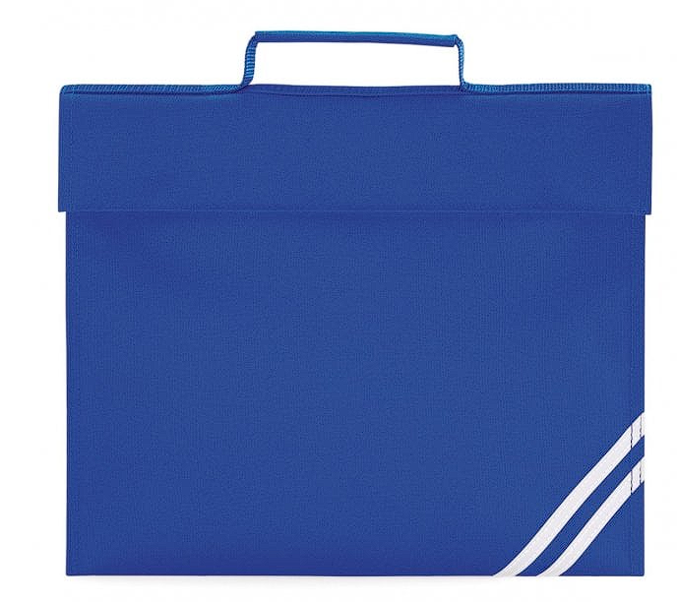 | School logo optional  No branding | Available from uniform supplier  Can be bought from regular retailers | £7.02  From £5.00

- High heels, flip flops, crocs and strappy sandals are not permitted.
- Children must have a coat appropriate for the time of year. We discourage parents from sending children to school in expensive, branded coats or light coloured coats which can get dirty. Coats must be marked with the child’s name.
- School cannot take responsibility for items of clothing which are lost. All lost property is available for parents to look at before and after school.

Jewellery
Permitted jewellery that may be worn is:
- One pair of stud earrings – No other piercings are permitted. No Hooped Earrings
- A smart and sensible wrist watch.- No smart watches

All jewellery must be removed during practical lessons e.g. PE lessons and science experiments. Children must be able to remove them independently.
Jewellery is the responsibility of the pupil and not the school. Lost or damaged items will not be refunded.

School bag
Children only need to bring their reading book, homework, and packed lunch if appropriate. Pupils do not need a large bag.
The school encourages pupils to bring non-valuable bags to school. The school will not be liable for lost or damaged school bags.

Hairstyles

Pupils with long hair must ensure that this does not impede their vision, cover their face or provide a health and safety risk. Long hair must be tied up during practical lessons, e.g. during PE.

Makeup
Make-up is not permitted.
This includes:
- False nails and nail extensions
- False Eyelashes

If children come to school wearing any of the above, school will contact parents to discuss

Labelling
All pupils’ clothing and footwear must be clearly labelled with their name.
Any lost clothing is kept within Phases. All lost property is retained for a term and is disposed of if it is not collected within this time.

9 Uniform supplier

Our current school uniform supplier is:
- Tots to Teams
- Address: Unit 10b, Airport Industrial Estate,
Kingston Park, Newcastle upon Tyne
NE3 2EF
- Telephone: 0191 271 5454
- Email: orders@totstoteams.com

10 Uniform assistance

We aim to support parents/carers experiencing barriers in providing the correct uniform for their child.

The ‘Community School Clothing Scheme’ is located on Wallsend High Street West, who stock items of uniform for free.
They also take donations of good quality uniform items, so please recycle unwanted items in the orange collection bin outside the front of school.

Please contact the school office for any further information.

All requests for amendments to the uniform policy are dealt with on a case-by-case basis and we are committed to finding a mutually acceptable solution wherever possible.

11 Complaints

Any complaints about this policy or its implementation should be raised under the schools Complaints Policy and Procedure. Complaints should be raised informally with the school in the first instance to give us an opportunity to resolve the matter quickly.

General
This policy is at the discretion of the Governing Body and can be varied at any time. In the event of any conflict with primary legislation or statutory regulations, the legal provisions will have precedence over this policy in all cases.

